Introduction

ISLAM:

Meaning: Islam means “peace”, “submission” or “surrender”.
In Islamic sense, it means to show total submission to the will of Almighty Allah and to obey His commandments without a question.
Every Person who says Kalima;

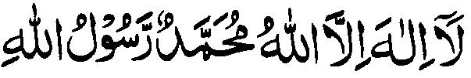

(“None is worthy of worship except Allah, Hazrat Muhammad S.A.W is the last prophet of Allah”)

He accepts Allah’s unity and believes in His oneness along with believing in His Messenger Muhammad (P.B.U.H)’s Prophet Hood thereby becoming a Muslim. The first part of this Kalima deals with the unity of ALLAH. ALLAH Is the Creator, The sustainer, the supreme, no one is worthy of worship but him. The second part of kalima, tells that MUHAMMAD (P.B.U.H) is the messenger of ALLAH, and we should follow, and obey the message that he has brought.
Allah sent his messengers; Hazrat Adam A.S till Hazrat Muhammad S.A.W, Collectively they were about 1 lack 24 thousand messengers in number. They were all sent by Allah to this earth for one single purpose; to spread his teachings in mankind, to guide them towards the straight path and to make them believe in the oneness of God. In the eyes of Allah, there is only one right Religion i.e. Islam.

SURAH_ALIMRAN #19

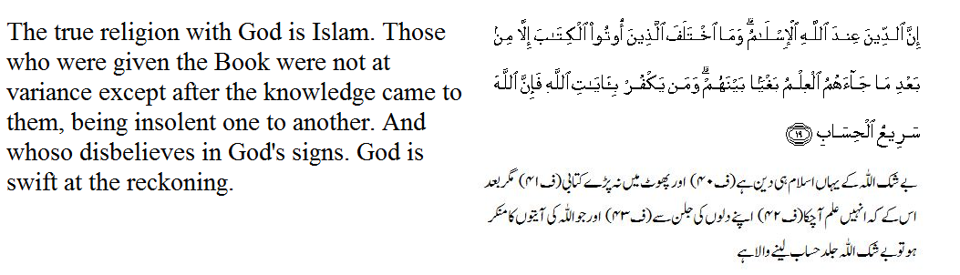

Before Quran, even after revealing all the Holy books and sending various messengers, the purpose of complete guidance and righteousness of mankind was still unaccomplished, as people made changes to their own liking in the revealed books and amended whatever was commanded to them. Made partners in worship of Allah and did shirk (polytheism) openly, defying Allah’s commandments. So, Allah sent Holy Prophet SAW as His last messenger with Quran as a final revealed book, with a complete code of life. He then himself took responsibility of protecting this Holy Quran from any future changes, maintaining the eternal beliefs and laws of a pious life with a complete code of conduct, thereby accomplishing His purpose. And that is why the chain of prophets and messengers at last became finalized and Holy Prophet SAW became the last prophet of Allah; Khatim-un-Nabiyyin (the seal of Prophets.) Before Prophet (PBUH)’s death; Allah revealed about the accomplishment of His purpose:

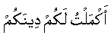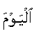
“Today I have perfected your religion (deen) for you”

Approach to Islamic Beliefs:

The approach to the presentation of Islamic beliefs and practices depends upon the addressee's religion and culture. A reference point of commonalty or contrast is useful. For example, the Christians believe in the "original sin"; the connotation is that a human being has the stigma of being born as a sinner and is dirty filthy by nature. What has a newborn done to be a sinner or to be a filthy person? Contrast this with the Islamic teaching that every human being is born in nature, meaning good with no stigma of any kind and, if left alone without any brain washing will do no wrong. Such a person has a natural ability to distinguish between right and wrong and his tendency is to do right. In the society which raises a person brain washed, many times when he reaches puberty he is all confused – good has become bad and bad has become good under the influence of the society. He was not dirty by birth but the society has made him dirty in beliefs and practices.

Purification

When clothes get dirty, they are washed; when the body gets dirty, a bath or a shower is in order. Similarly, when beliefs and practices have become dirty, a purification job is in order and this purification is the entry into Islam through the door of witnessing or shahadah. Once a person has entered Islam he is purified as a newborn and has a second chance to start over again. His past sins are washed away while keeping his good works as assets.
Analogy of a Building
There are two aspects of purification: (a) physical, and (b) spiritual. Physical purification consists of purifying the body, clothes and environment. Spiritual purification consists of purifying beliefs and practices (works or deeds). The analogy of Islam is that of a building. A building has its foundation, pillars, roof, walls and other components. The foundation of a building is underground and not visible; similarly, the foundation of Islam consists of beliefs and remains invisible. The pillars, walls, roof and other parts of a building are visible. Similarly, what a Muslim says and does is visible and becomes the pillars, roof and walls of Islam.

AQEEDAH (BELIEF): It is derived from an Arabic word; “aqad”. Meaning of Aqeedah is ‘to tie a knot’. In Islamic sense, it means; to strengthen the faith (Iman), or a stubborn/firm belief coming from heart.
Some definitions for ‘Aqeedah’ according to religious scholars:

PROFESSOR MAULANA MUNEEB-UR-REHMAN:

Meaning of “Aitiqaad” is ‘to verify something then believe in it very firmly and adopt it according to our religious ways.’
Aqeedah includes all those attributes in which a person believes very strongly and firmly and adopts them as the religion states.

PROFESSOR MAULANA SYED ATAULLAH HUSSAINI QADRI:

Aqeedah is the singular of Aqa’id and is derived from word Aqad which means ‘to tie a knot and tying firmly and strongly’. Aqa’id are those firm, unwavering, undoubtful beliefs of a person around which all his thoughts and actions revolve and towards which all his deeds are centered. These principled thoughts are the one which build or ruin a person.

PROFESSOR MUHAMMAD ARSHAD BHATTI:

Aqeedah means “Faith from heart”. Actually it is said as such because a person when believes in any principle form heart, he, as though, ties those principles and thoughts with his heart and mind and holds them firm and strong. Aqeedah can also be called as “Imaniyat – Faith” and “Nazariyat – Theories”.
PROFESSOR NASEEM WAHIDI SAHIBA:

Behind person’s every deed and action, there is always a firm intention or a plan and that plan is motivated by a thought and these thoughts are effected by heart’s intentions, that’s why every deed or action is dependent upon the intentions behind them.
The firmness of these thoughts and theories is what we call as Aqa’id –Beliefs, after which there is no room for doubt and person is compelled to act accordingly; this condition is called Iman - Faith.
Now, Iman or Aqeeda has two essential components which have to be fulfilled:

- IQRAR (ACCEPTANCE): Means accepting the beliefs by saying them in words with mouth.
- TASDEEQ (VERIFICATION): After accepting them with words, Verifying them through our heart and actions.

IMAN-E-MUJAMMIL:

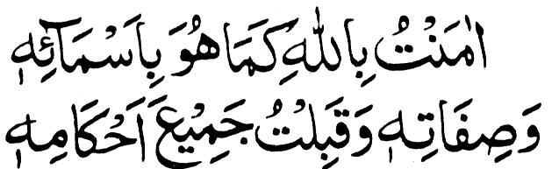

(I have faith in Allah as He is known by His Names and attributes and I accept all His commands.)

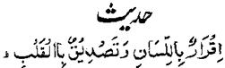
(Acceptance is with words and verification with the Heart)

IMAN-E-MUFASSIL:

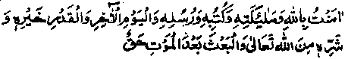
(I have faith in Allah and His Angels, His Books and His Messengers, and the Day of
Judgment and that all good and evil and fate is from Almighty Allah and it is sure that
there will be resurrection after death)

BASIC BELIEFS OF ISLAM:

There are five basic Islamic beliefs at which our faith should be firm and strong. These five beliefs are all beliefs about the ‘unseen’ i.e. ‘Ghaib’. Not believing in even one single belief will lead a person from boundary of Islam towards kufur.

These five beliefs are:

- Tauheed – Belief in oneness of God.
- Risaalat – Belief in Prophet Hood.
- Mala’ika – Belief of Angels.
- Ilhami kitabe’n - Belief in Holy Books.
- Yaum-ul-Akhira – Belief In the Day of Judgment.

These five beliefs are interconnected in such depth that affirmation of one automatically requires affirmation and belief of another.
And negation and defying of one will automatically lead to defiance of all.
And without believing in every single belief, our Faith will not be fulfilled and we will not be called true ‘Mo’mins’ i.e. ‘the faithful ones.”
Iman (Faith) is the actual essence of our deeds, Faith is the spirit and deeds are its body, faith is the claim and deeds are its proof!
That is why without Faith (Iman – Belief), our actions, performances and deeds are like a soulless body!
As according to Islam, if there is no Iman, however much beautiful the actions are, there is no reward for them in after life. This is like a tree without shade or fruit; so it is considered vain.

SAYING OF THE PROPHET MUHAMMAD (P.B.U.H) ABOUT FAITH:
The Holy Prophet MUHAMMAD (P.B.U.H) said your firm belief in ALLAH, His angels, His holy books, His Messengers, Dooms Day and in the truth of Divine destiny good and bad is called faith. (Bukhari and Muslim).

Upon entering the boundary of Islam, there is a basic condition to be fulfilled firstly i.e. Kalma-e-Tauheed or Kalma-e-Shahadat, it is the initial point where the building of Islam is built, It is the axis around which the whole Islamic system rotates.
(“None is worthy of worship except Allah, Hazrat Muhammad S.A.W is the last prophet of Allah”)

- Belief in Oneness of God - (TAUHEED: Monotheism):

The term Tauheed, also called monotheism (belief in one God); demands a lengthier translation, namely: “the realization-and-affirmation-of-Oneness”, the unity of God i.e. the divine unity, unity in its most profound sense. Allah is The Real, The Absolute. Allah is one in His Essence, His Attributes and His Acts. Before the existence of the universe there was nothing but The Creator.
The Qur`an declares that “Nothing is like Him” (42:11). Allah is omniscient and all-powerful. All of Allah’s attributes belong to Him exclusively. He is the first and there is no last but His oneness. He is the First without anything before Him. He is the Last without anything after Him. The end is with Him alone, and He is the End. He is All-Existing: with him there is no end. Allah is now as He was before. He is Eternal.
Belief of Tauheed requires to worship only Allah, Almighty and do not believe in other gods. This belief is also called; “Iman Billah” – Faith in God. This is the elementary and fundamental teaching of Islam. It not only means to believe in oneness of Allah’s entity but also to believe in His attributes and powers which are exclusively His.

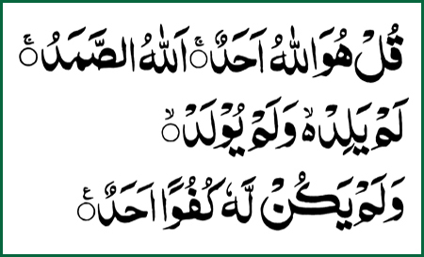

{Say: He is Allah, the One!
Allah, the eternally besought of all!
He beget not nor was He begotten.
And there is none comparable unto Him.}

Belief In God And His Attributes:
Muslims believe in one, unique, incomparable God, Who has neither son nor partner, and that none has the right to be worshipped but Him alone. He is the true God, and every other deity is false. He has the most magnificent names and sublime perfect attributes. No one shares His divinity, or His attributes. In the Quran, God describes Himself:

The Arabic word Allah means God (the one and only true God who created the whole universe). This word Allah is a name for God, which is used by Arabic speakers, both Arab Muslims and Arab Christians. This word cannot be used to designate anything other than the one true God. The Arabic word Allah occurs in the Quran about 2700 times.
God alone is the Almighty, the Creator, the Sovereign, and the Sustainer of everything in the whole universe. He manages all affairs. He stands in need of none of His creatures, and all His creatures depend on Him for all that they need. He is the All-Hearing, the All-Seeing, and the All-Knowing. In a perfect manner, His knowledge encompasses all things, the open and the secret, and the public and the private. He knows what has happened, what will happen, and how it will happen. No affair occurs in the whole world except by His will.

Whatever He created He knows in its minutest detail, hence He is All-Knowing. Similarly, He is All-Seeing, All-Hearing, Most Compassionate, Most Merciful, Forgiving, Just; He has many attributes or good names – Muslims are told that He has ninety-nine names. All of His names are not abstract words but they have relevance in every Muslim's life. He created everything and humankind for a purpose: to serve Him. The God, in Islam, is the bedrock of the foundation of Islam.

Belief in Prophet Hood:
Belief in Prophet Hood is the second most important doctrine of Islam. Prophet Hood (Risalat), according to the dictionary, means communicating or imparting a message. The bearer of the message in religious terminology is called a ‘Rasul’ or Prophet whom ALLAH has sent for propagating his teaching to the people. A ‘RASUL’ is also called a ‘Nabi’. A Nabi is one who imparts news or information. Because a Prophet informs the people of the commands of ALLAH he is also called a ‘Nabi’.
Only Allah can tell the purpose of the creation of humankind which He does through his chosen human beings called prophets and messengers. Islam recognizes many prophets of the Bible, such as, Noah, Abraham, Moses, Jesus and many in between them.

Belief in Angels

The Arabic word ‘Malaika’ is the plural of ‘ malaik’ which means messenger. In the Holy Quran, angels are spoken of as “messenger” which denotes their spiritual function of bearing Divine messages. Like Tauheed and prophet hood , it is also essential to believe in the existence of angels.

They are the creation of Allah, scattered all over the universe doing the work for Him. Human beings have been given very little knowledge about angels. One much honored angel, Gabriel or Jibra’il, brought Allah's guidance to the prophets. Along with other angels mentioned in the Qur'an there are two angels with each human being, writing his deeds.

Belief In Revealed Books:
When one accepts a new job he is given a job description and someone shows him how to do various tasks. Similarly, Allah gives the job description in His revelations and the Prophet shows the meaning and implementation of what and how. All the prophets of the Bible fulfilled their duties and the last prophet, Muhammad, did also. He left behind the Word of Allah, the Qur'an, and his teachings, Hadith, were collected by his companions. The Qur'an and the Hadith are the textual sources of Islamic teachings and will remain so as long as there is life on earth. Allah Himself has taken the responsibility for their preservation.

Belief In Day Of Judgement

Muslims believe in the Day of Judgment (the Day of Resurrection) when all people will be resurrected for God’s judgment according to their beliefs and deeds.
Allah is Just but there is much injustice on earth. Murderers are getting away with murders, embezzlers are getting away with their loot, dictators are getting away with their oppression and injustices, and other criminals are getting away with their crimes. Are they really getting away with their crimes? No, it only appears that way. Everyone will be accountable for his deeds to Allah on the Day of Judgment and will receive reward or punishment. The life of the earth is the life of trials, not the place of real reward or punishment. This leads to the reality of Life Hereafter. After destruction of life on earth Allah will command human beings to come back to life with body and soul, their resurrection. Resurrection is followed by the judgment by Allah. No judgment is complete without reward for good doers and punishment for evil livers. The reward is the life of paradise and punishment is the life of hell. Both are believed to be eternal.

Belief In Al-Qadar
People are created as males and females, short or tall, black, white, brown, yellow, smart or not so smart, with appointed parents, having a given time and place of birth and death and so on. All this is decreed by Allah. However, human beings have choices and enjoy limited freedom. The result of their activities depends upon their level of knowledge, level of effort and permission of Allah to succeed. Since human beings do not have perfect knowledge, sometimes they succeed and other times they fail in their pursuits. The admission that only Allah has perfect knowledge and human knowledge is imperfect and practical implications of this admission is Qadr.

The belief in Divine Predestination includes belief in four things:
1) God knows everything. He knows what has happened and what will happen.
2) God has recorded all that has happened and all that will happen.
3) Whatever God wills to happen happens, and whatever He wills not to happen does not happen.
4) God is the Creator of everything.

EFFECTS OF BELIEF OF TAUHEED ON HUMAN LIFE:-

Redemption from worship other than Allah:

- The person, who has firm belief in Allah and His oneness, will also believe in Allah’s attributes, His powers, His wisdom and Knowledge. He will believe that all sovereignty belongs to Allah only. That’s why, he will never bow to any other person’s will, will never fear anyone other than Allah. As he thinks that, all heavenly bodies; sun, moon, stars, and angels, genies, spirits, fire, mountains etc all are under Allah’s commandment, he will never try to ascribe partners to Allah.

Identification of Status of Human Beings:

- As he believe in Allah’s oneness and will become close to Allah, he will realize that his life in this world is due to some reason and nothing is meaningless. He will realize his true self and place in this world. He will know that all this world’s facilities are made and given to his control; he is different and superior to other creatures due to his wisdom. Now his duty is to serve the purpose for which he is sent.

Qualities of Self Correction; Justice; Generosity; Braveness in the Human Beings:

- As the belief in Allah gets stronger, the belief that; life and death, food, health and other necessities are all provided by Allah too, He is the one who is “Sam’ee”; one who listens and “Baseer”; one who sees. He knows us inside out. And He is the Master of the Judgment. This way a person will try to treat everyone with justice; will spend money in the way of Allah and for welfare of mankind as he believes that the money spent for Allah will never go to vain. He also becomes fearless to death as his faith strengthens.

Universal Brotherhood and Sense of Humanity:

- A beautiful, universal sense of fraternity evolves as all believers of Allah believe in the overall equality of people. They disregard the differences and discrimination of race, color, wealth, classes, sects, tribes, castes etc; as Islamic boundaries are beyond the so-called standards of discrimination. And as the love for mankind and spirit of brotherhood spreads, people feel for each others’ pain and sorrows, they start caring for each other.

Redemption in worldly life and Hereafter:

- For ages, man has tried to find and maintain a system to ensure success for both the worlds. In this search for a better organization of system, man has tried with his limited wisdom and materialistic approach; so he never succeeded. Because for betterment, he has to see beyond his own benefits, has to be selfless, has to think for a general success and welfare of mankind. That spirit comes from the beliefs of Islam and its teachings, so only the one having those believes will be able to get self correction (Islah-e-Nafs), success (Falah), Redemption (Nijaat) and guidance.

SHIRK : POLYTHEISM:-

Shirk literally means, “partnership”, “company” or “association”. It another term is, ‘Polytheism’ i.e. belief in many gods. It is the opposite of monotheism; Tauheed, which means belief in only one God. Polytheism or ascribing partners or associating partners in worship of God, in His attributes, His entity, all are included in Shirk.

Shirk in Oneness of God:-

Shirk in oneness of Allah is a major kind of Shirk which is not forgiven by Him. There is no room for partnership in Allah’s domain. He is the sole Creator and Master of all mankind. He is the only one capable of all powers and ascribing partners unto Him, believing that any other human or idol have that sovereignty which belongs to Allah only; this all includes in “Shirk fiz Zaat”; Partnership in Allah’s entity.

Shirk in Worship and Divinity of Allah:-

It involves the devotion of all some acts of worship to false gods other than Allah. Allah is the only one worthy of worship, and worshipping others instead of Him or in association with Him is pure sin. Believing someone to be His son and ascribing false idols as partners to Him are all included in Shirk fil-Iba’dah ; Partnership in Allah’s worship.

Shirk in Attributes of Allah:-

All those powers and qualities which are only exclusive to Allah, ascribing partners in them is also a kind of Shirk. Believing someone other than Allah to be capable of superior powers, power of creation, being capable of providing food etc and believing someone other than Allah to be eternal is all part of Shirk. It is called “Shirk fis-Sifaat” – (Associating Partners in Attributes of Allah).

Shirk in Allah’s Power:-

Allah is the Controller and Superior master of all. All powers belong to Him only. We all are under His rule and dependent upon His commandment. So, ascribing partners in His powers (Iqtidaar/Qudrat) is a major Shirk. Wherever the man’s wish or rule collides or opposes with Allah’s rule and commandment, then and there it should be cancelled and rejected as it is against the belief of Tauheed.

